**ITA0448 – STATISTICS WITH R PROGRAMMING FOR VECTORIZED EXPRESSIONS**

**SUBMITTED BY: DEVADARSHINI J REG NO: 192124092**

**DATE: 21/03/2023**

1. **How to use the cbind() and rbind() in data frame for the fields city and zipcode datas using vector and data frame.**

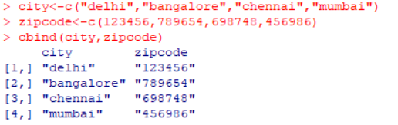

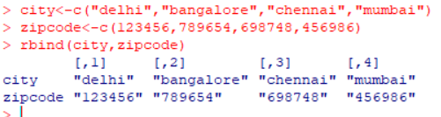

1. **Create First Dataset with variables**

**● surname**

**● nationality**

**Create Second Dataset with variables**

**● surname**

**● movies**

**The common key variable is surname. How to merge both data and check if the dimensionality is 7x3.**

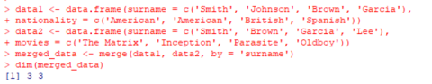

1. **Write a R program to create an empty data frame.**

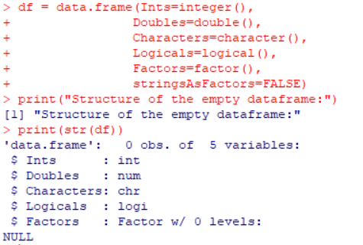

1. **Write a R program to create a data frame from four given vectors**

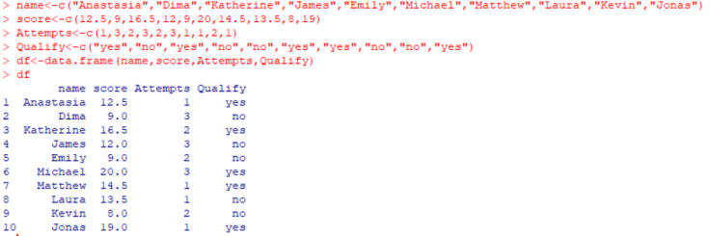

1. **Write a R program to extract specific column from a data frame using column name.**

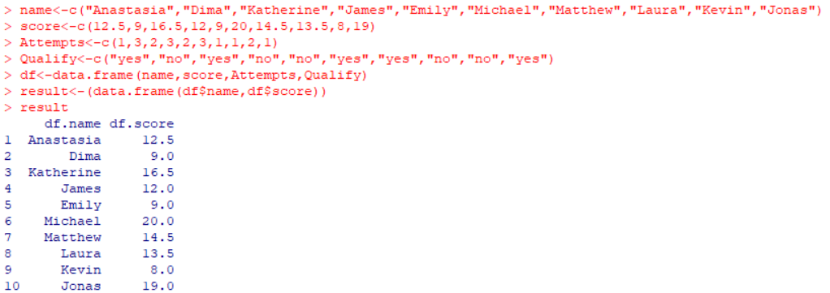

1. **Write a R program to extract first two rows from a given data frame.**

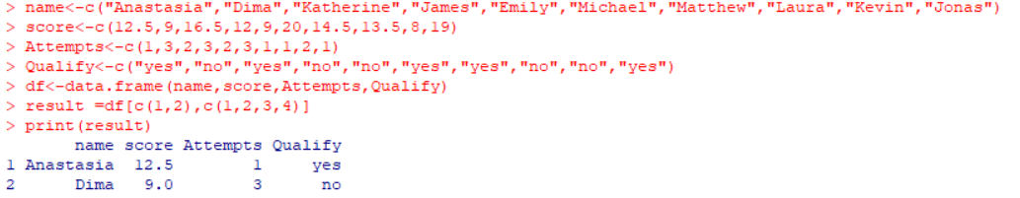

1. **Write a R program to extract 3 rd  and 5 th  rows with 1 st  and 3 rd  columns from a given data frame.**

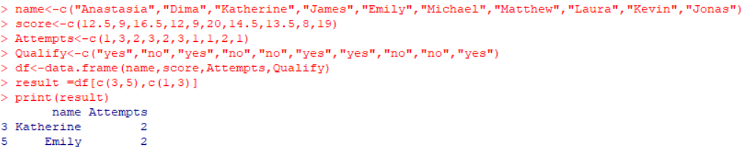

1. **Write a R program to add a new column in a given data frame**

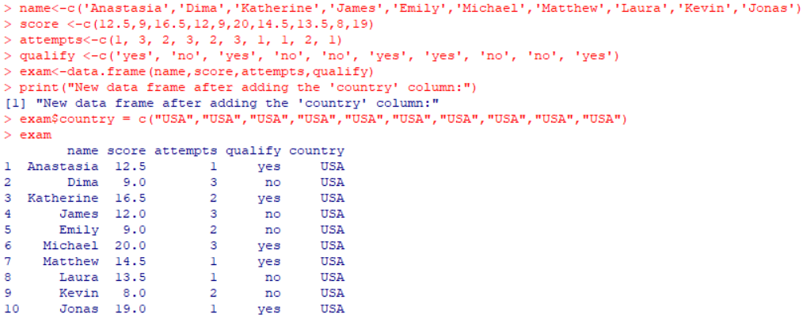

1. **Write a R program to add new row(s) to an existing data frame.**

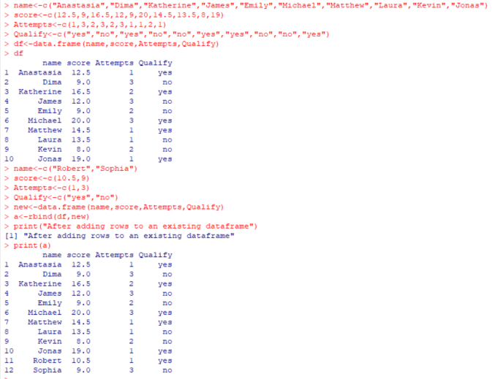

1. **Write a R program to drop column(s) by name from a given data frame.**

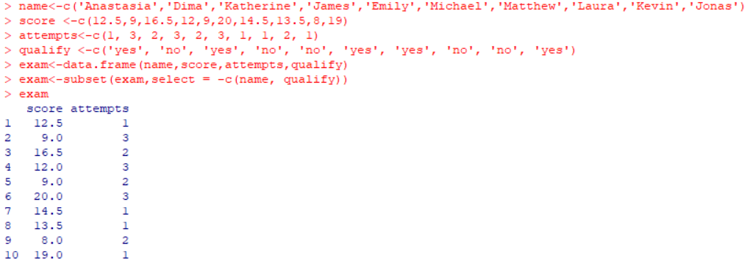

1. **Write a R program to drop row(s) by number from a given data frame.**

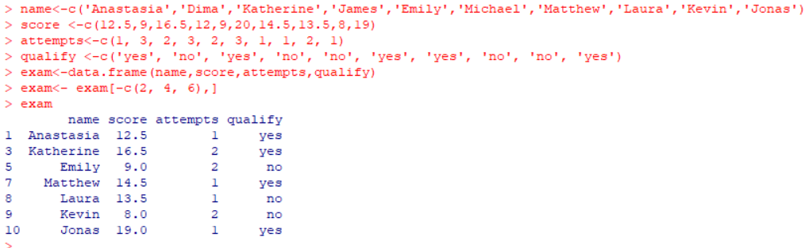

1. **Write a R program to sort a given data frame by multiple column(s).**

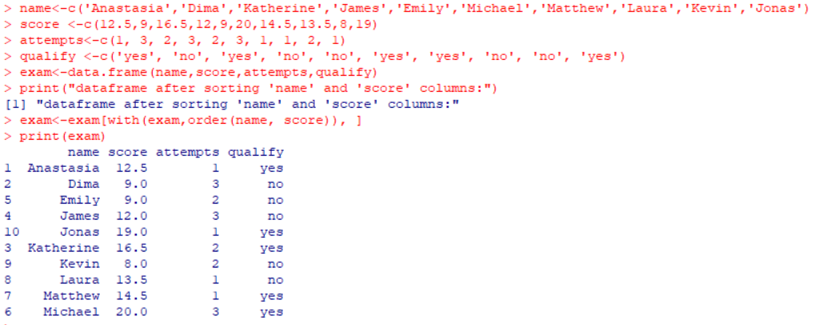

1. **Write a R program to create inner, outer, left, right join(merge) from given two data frames.**

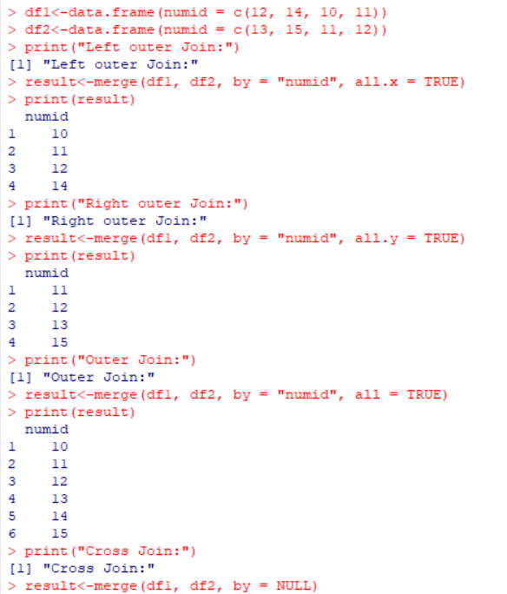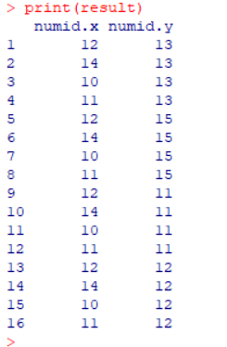

1. **Write a R program to replace NA values with 3 in a given data frame.**

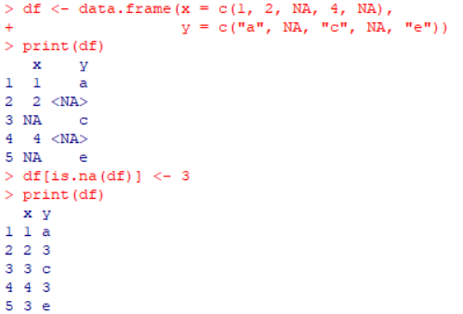

1. **Write a R program to change a column name of a given data frame.**
2. **Write a R program to change more than one column name of a given data frame.**

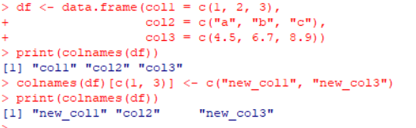

1. **Write a R program to select some random rows from a given data frame.**

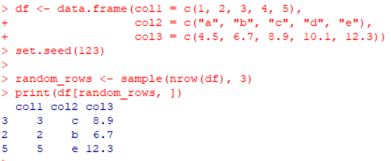

1. **Write a R program to reorder an given data frame by column name.**

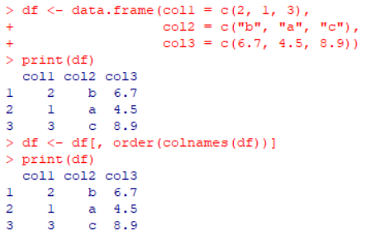

1. **Write a R program to compare two data frames to find the elements in first data frame that are not present in second data frame.**

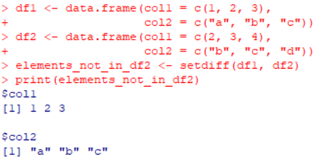

1. **Write a R program to find elements which are present in two given data frames.**

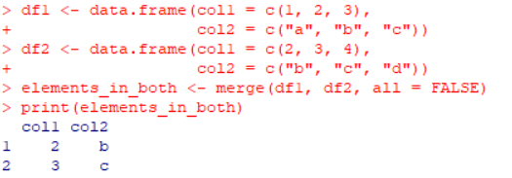

1. **Write a R program to find elements come only once that are common to both given data frames.**

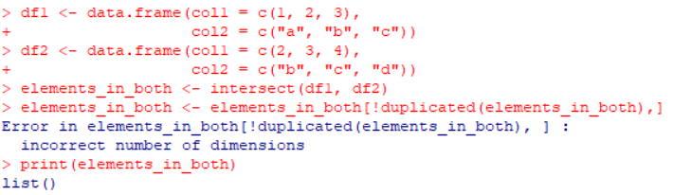

1. **Write a R program to save the information of a data frame in a file and display the information of the file.**

